CURRICULAM VITAE 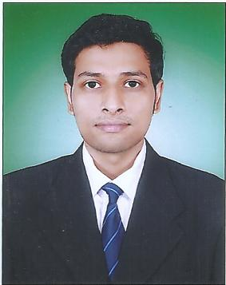

NAME: - Sourav Panda
DATE OF BIRTH: - 25-03-1990
FATHER’S NAME: - Ramapati Panda
MOTHER’S NAME: - Monika panda
PERMANENT ADDRESS: - Vill-Bahalia, po- Mahisagote , contai,
Dist. - Purbamedinipur, Pin-721401

PRESENT ADDRESS: - 95/A Pallysree colony,1st Floor,kolkata-92

PHONE NO: - 9883955949/ 8013655944
EMAIL-ID: - coolsourav80@gmail.com
OBJECTIVE
To start up a career in an organization where I can get the opportunities to explore my potential & skill for the growth of the organization and to get best out of myself both as an employee and as an individual.

EDUCATIONAL QUALIFICATION

NAME OF EXAMINATION |  | BOARD/  UNIVERSITY | YEAR OF PASSING | PERCENTAGE
SECONDARY  EXAMINATION |  | W.B.B.S.E. | 2006 | 64 %
HIGHER SECONDARY |  | W.B.C.H.S.E. | 2008 | 77%
BACHELOR IN HOSPITAL MANAGEMENT(BHM) | W.B.U.T |  | 2012 |  | 65%
PGDM (2 Yrs Full Time) | AICTE |  | 2014 |  | 70%

TRAINING:

- On job` training in Belle vue clinic during the summer internship program from 15th may2013 to 30th Jun2013, in HR department.

EXPERIENCE:
- One year six month work as a marketing executive in a real estate company (Saraswati Infracon India ltd). Project name is “GREENVILLE” [August 2013-Dicembar 2014]
- One year experience in a real-estate company as a Marketing Manager (Vriddhi Landmart Pvt Ltd). [january2015-decembar2015]
- Currently work in Simoco systems and infrastructure solution ltd. Project name is ‘SANHITA’.[December 2015- continue]
SKILL:
- Computer application (MS word and excel) from CMC
- Good communication & team building skills.
- Positive Attitude to Negotiation Skill.
- Possessing ability of multitasking under stressful conditions.

LANGUAGE: Bengali, English, Hindi (R, W, S).

AREAS OF INTEREST:
- Painting.
- Networking, interacting with the people of different culture.
- Watching Cricket and Live concerts.

declaration
I do hereby declare that the information given above is true to the best of my knowledge and belief.


DATE: -
_____________________
PLACE: KOLKATA S I G N A T U R E

